Method

* Function stored in a property of an object

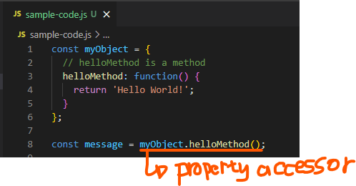

Method invocation

* Expression in a form of “property accessor” is followed by (args)
* obj.method() or obj[‘method’]()

Major Difference from Function Invocation

* Method invocation requires a property accessor form to call the function

